***ORIGINAL DATASET BEFORE TRANSFORMATION***

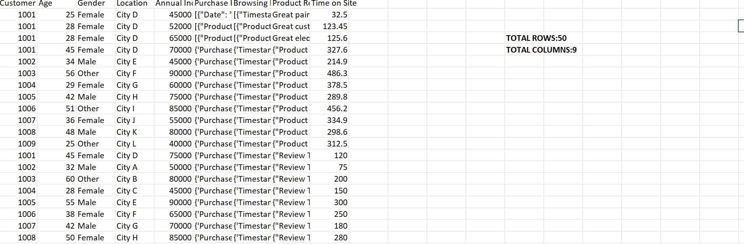

***DATA AFTER CLEANING AND TRANSFORMATION***

